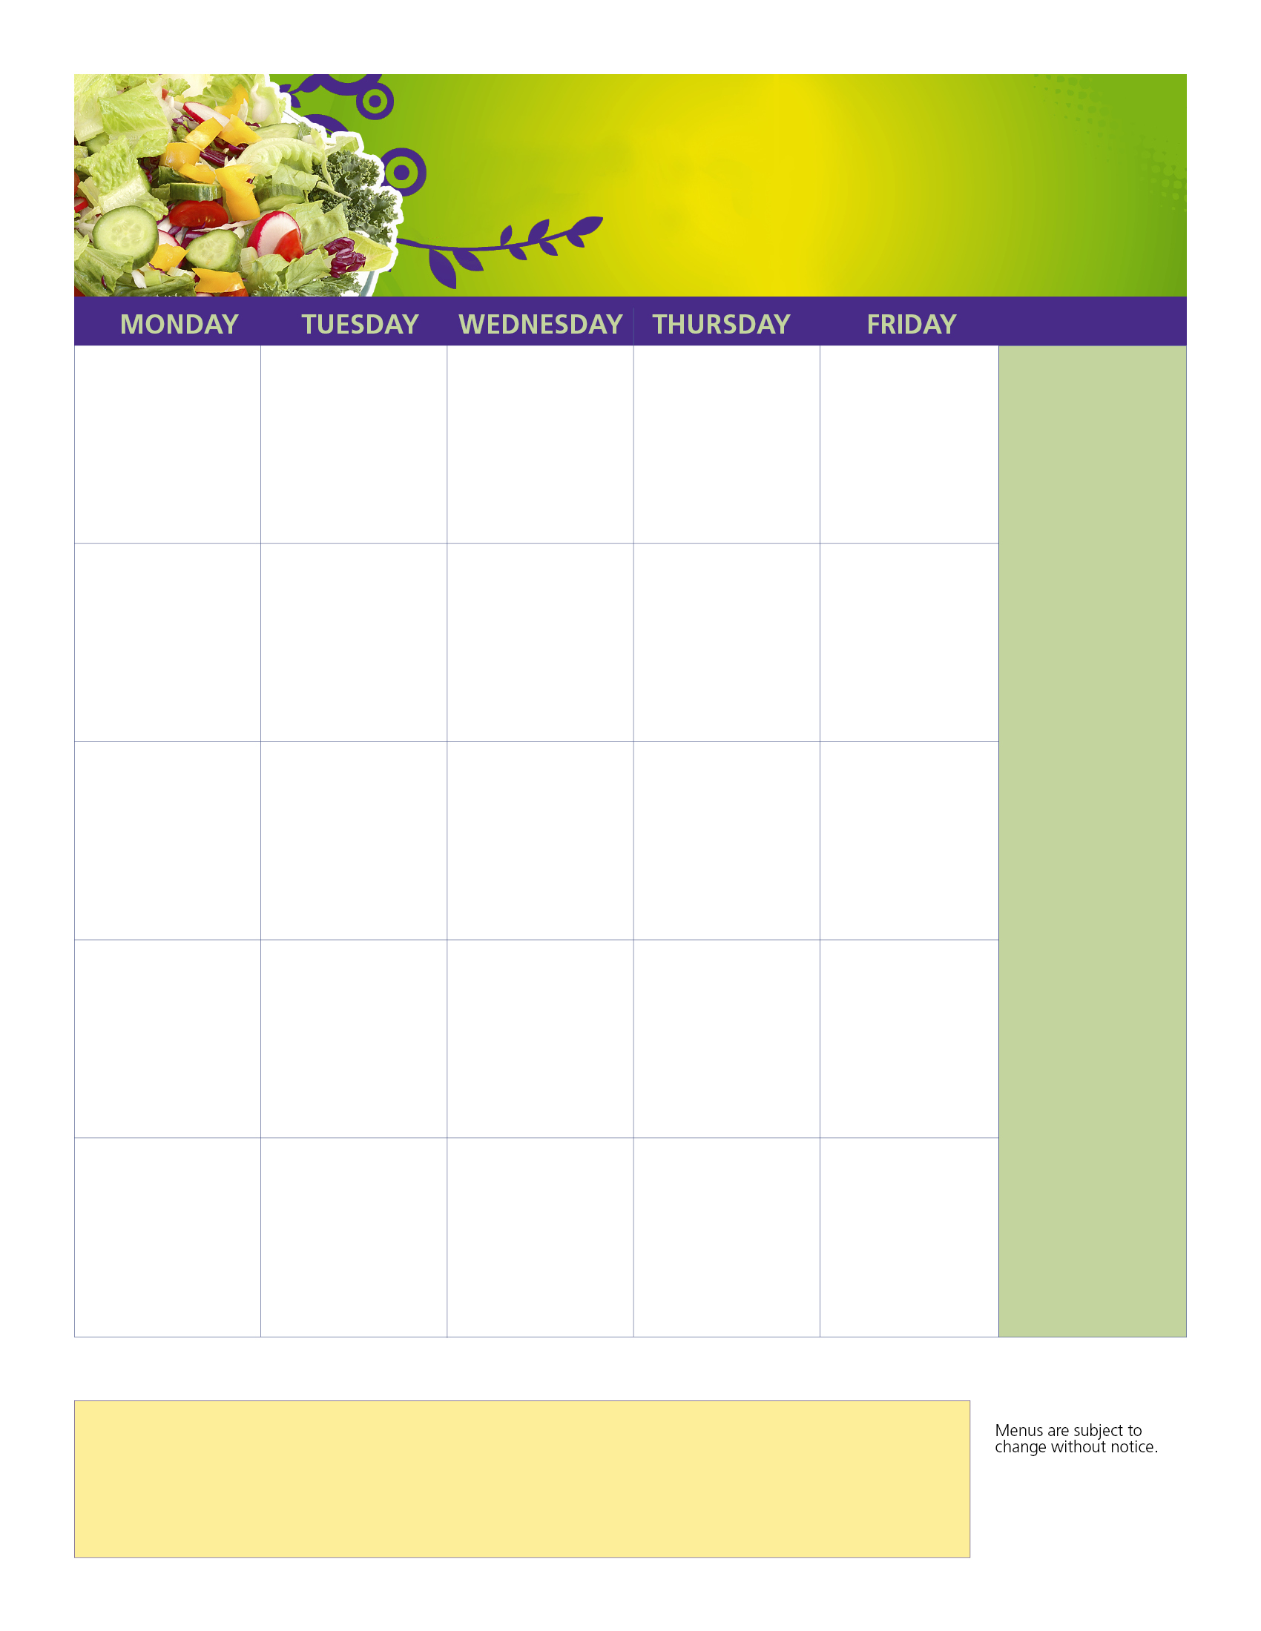

**Cheese Pizza (V)**

**Chicken Nuggets**

**Bagel Cool Kit(V)**

Sweet Corn

Orange Smiles

Ice Cold Milk

**Warm Pretzel Roll W/Yogurt &**

**Cheese Stick (V)**

**Chicken Nuggets**

**Bagel Cool Kit (V)**

Cherry Tomatoes

Juicy Grapes

Ice Cold Milk

**Parents, please be sure to fill out an application in order to receive additional benefits**

**Welcome Back!!**

**All Students eat Free Breakfast & Lunch all Year!!**

**All Students Eat Breakfast & Lunch Free!**

**2nd Meals or Snacks are extra please make payments**

**online**

**Daily Meal**

**-Chicken Nuggets**

**-Muffin or Bagel Kit**

**Every meal comes complete with fruit, veggies, and milk. We offer Skim Chocolate & 1% White**

**Chicken & Cheese Empanadas**

**Chicken Nuggets**

**Bagel Cool Kit (V)**

Garbanzo Beans

Juicy Plum

Ice Cold Milk

**Waffle W/**

**Chicken Sausage Patty**

**Chicken Nuggets**

**Bagel Cool Kit(V)**

Potato Smiles

Juicy Grapes

Ice Cold Milk

**Grilled Cheese(V)**

**Hummus & Veggies W/String Cheese(V)**

**Chicken Nuggets**

**Bagel Kit (V**)

Baby Carrot Sticks

Apple Slices

Ice Cold Milk

**French Toast W/**

**Chicken Sausage Patty**

**Chicken Nuggets**

**Muffin Cool Kit(V)**

Potato Smiles

Fresh Blueberries

Ice Cold Milk

**Chicken Fingers W/Dipping Sauce**

**Chicken Nuggets**

**The Muffin Cool Kit(V)**

Potato Smiles

Granny Smith Apple

Ice Cold Mild

**Cheese Pizza (V)**

**Chicken Nuggets**

**Muffin Cool Kit(V)**

Sweet Corn

Orange Smiles

Ice Cold Milk

**Cheese Ravioli (V) W/Marinara Sauce**

**Chicken Nuggets**

**The Muffin Cool Kit(V)**

Cherry Tomatoes

Apple Slice

Ice Cold Milk

**French Toast W/**

**Chicken Sausage Patty**

**Chicken Nuggets**

**The Muffin Cool Kit(V)**

Hash Brown Potato

Juicy Grapes

Ice Cold Milk

**Oven Baked Taco Bites**

**Chicken Nuggets**

**Muffin Cool Kit(V)**

Black Beans

Ruby Red Apple

Ice Cold Milk

**Macaroni & Cheese(V)**

**Chicken Nuggets**

**Bagel Kit (V**)

Baby Carrot Sticks

Apple Slices

Ice Cold Milk

**Turkey & Cheese on Croissant**

**Chicken Nuggets**

**Bagel Kit (V**)

Gold Fish

Celery Sticks

Granny Smith Apple

**Oven Baked**

**Mozzarella Sticks (V)**

**Chicken Nuggets**

**Muffin Cool Kit(V)**

Carrot Sticks

Granny Smith Apple

Ice Cold Mild

**Labor Day**

**No School**

**STRONG BODY ~ STRONG MIND**

**Vegetarian Meals = (V)**

**LUNCH & BREAKFAST FOR YOU**

**September 2021**

**6**

**Ball Park Frank**

**Chicken Nuggets**

**Muffin Cool Kit(V)**

Gold Fish

Garbanzo Beans

Apple Slices

Ice Cold Milk

**Cheeseburger**

**Vegetarian Burger (V)**

**Chicken Nuggets**

**Bagel Kit (V)**

Potato Smiles

Granny Smith Apple

Ice Cold Mild

**9**

**23**

**Waffles W/**

**Chicken Sausage Patty**

**Chicken Nuggets**

**Bagel Cool Kit(V)**

Potato Smiles

Juicy Grapes

Ice Cold Milk

**30**

**Cheese Pizza (V)**

**Chicken Nuggets**

**Bagel Cool Kit(V)**

Sweet Corn

Orange Smiles

Ice Cold Milk

**Chicken & Cheese Empanadas**

**Chicken Nuggets**

**Bagel Cool Kit (V)**

Garbanzo Beans

Juicy Plum

Ice Cold Milk

**1**

**1**

**Cheese Pizza (V)**

**Chicken Nuggets**

**Muffin Cool Kit(V)**

Sweet Corn

Orange Smiles

Ice Cold Milk

**8**

**14**

**2**

**21**

**10**

**27**

**28**

**20**

**13**

**15**

**16**

**22**

**7**

**24**

**17**

**3**

Go to :www.mySchoolBucks.com for prepayment of meals.

**Breakfast Menu**

Mon: Pillsbury Apple Strudel, Fruit Cup, Milk

Tues: Whole Grain Cereal Bowl, Graham Crackers, Fruit Cup, Milk

Weds: Blueberry Muffin Top & Graham Cracker, 100% Fruit Juice, Milk

Thurs: Whole Grain Cereal Bowl, Graham Crackers Fresh Fruit, Milk

Fri: Mini Pancakes, Fresh Fruit, Milk

This institution is an equal opportunity provider.

**More Info…**

**Use this space to highlight menu items/ beverages that are served every day to leave the date boxes for special items only.**

**Adjust type size ac-accordingly.**

Aramark_Education-sml