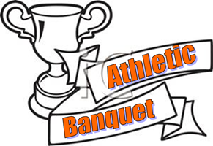

Booster Clubs Athletic Banquet 2021

DATE: May 27, 2021
TIME: 6:00PM
PLACE: Football Field

This year's Booster Club Athletic Banquet for all sports will be held on Thursday May 27, at 6:00pm on the football field.

Due to Covid restrictions and State guidelines, we will only be able to have our Seniors in attendance with no spectators. There will be some underclassmen guests invited based on awards.

Please pencil into your busy end of the year calendar the date of May 27, 2021.

If you have any questions please feel free to contact the athletic office at 781-279-3810 x1314.

