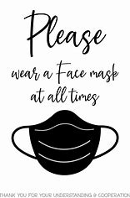

This message is a follow up to Superintendent Macero’s recent District Message regarding the DESE statewide requirement for wearing of masks in all public schools.
As the message stated the wearing of masks are now required for all employees, students, and visitors upon entering any SPS building. Masks are not required outside. Any further updates or changes will be communicated from the Superintendent. A copy of the DESE announcement is on our website. This directive is effective immediately, starting, August 26, 2021. Students, parents, and visitors are required to wear a mask upon entering Stoneham High School. The school will have masks available for those individuals in need. We appreciate your efforts in working through this and helping us maintain a positive and safe learning environment for our students.

Bryan Lombardi,
Principal

